**ST. JOSEPH’S COLLEGE OF ARTS & SCIENCE (AUTONOMOUS)**

**CUDDALORE-1**

**PG Department of Computer applications**

**Report on Hello World 202K**

Title of the Programme: **Hello World 2K24**

Date : **23.02.2024**

Venue : **St. Joseph’s college of arts & science (autonomous)**

**Cuddalore-1**

The PG Department of Computer Applications hosted an inter-collegiate technical competition named "**Hello World 2K24**" on 23.02.2024, from 9:30 AM to 5:00 PM. The event saw enthusiastic participation from students across multiple colleges, with approximately 200 participants representing 15 institutions. The competition aimed to unite students from different colleges to demonstrate their technical prowess, stimulate innovation, and promote collaboration among young technologists. This event provided students with a valuable platform to present and be recognized for their exceptional technical solutions. The following activities were done on that day*:* ***Paper Presentation, Technical Quiz, Web Design, SQL Clash and Code Drive.***

**Organizing Secretaries**

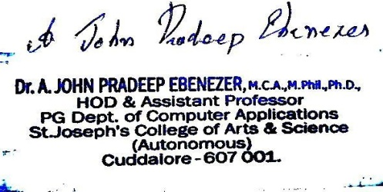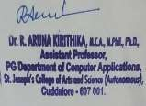 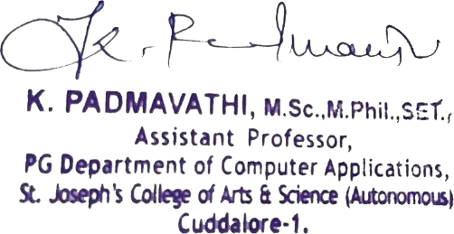

**Pamphlet**

**Front side**

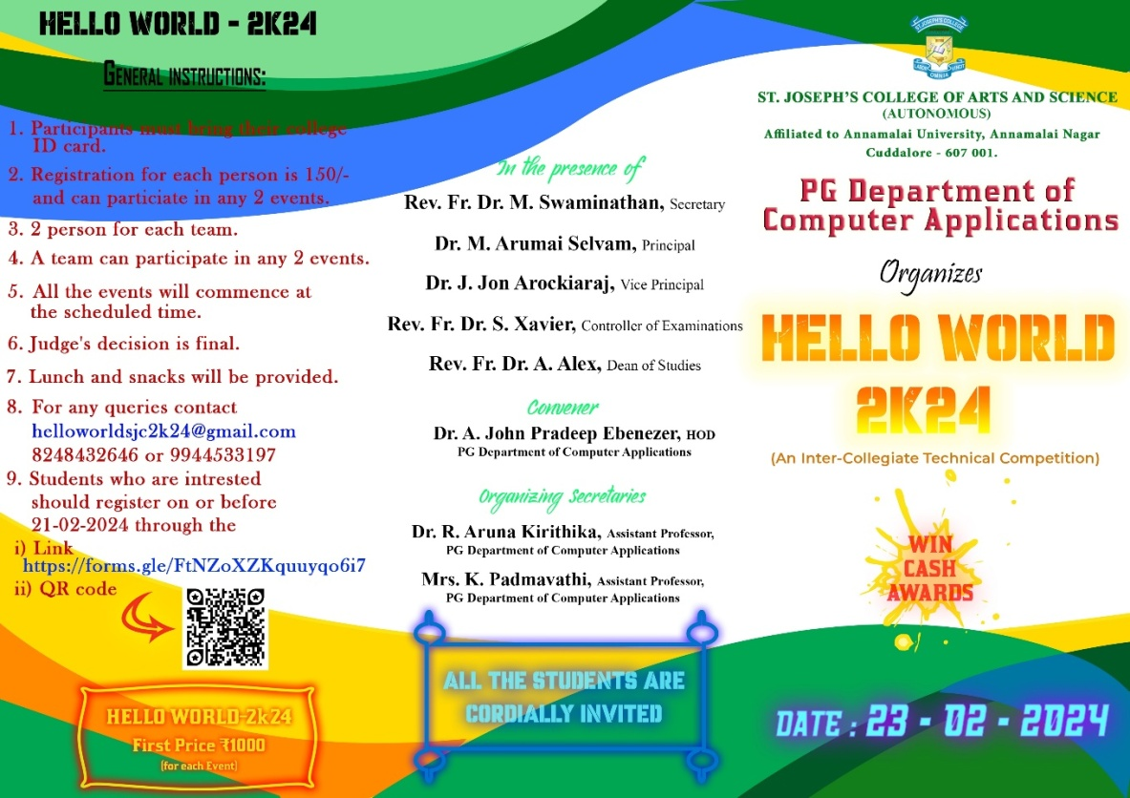

**Back side**

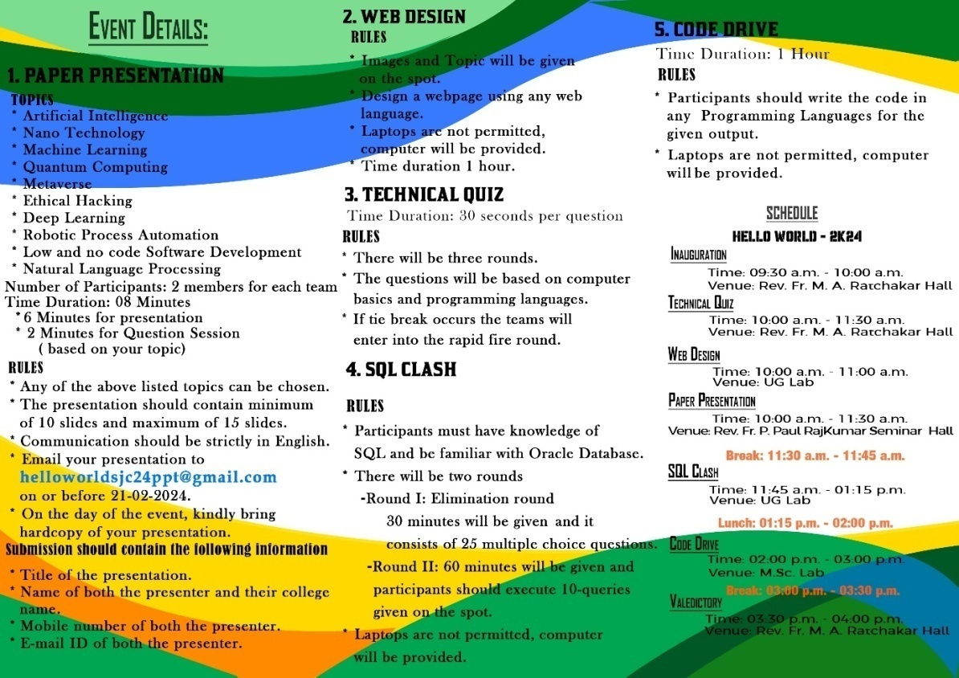

**Sample Certificate**

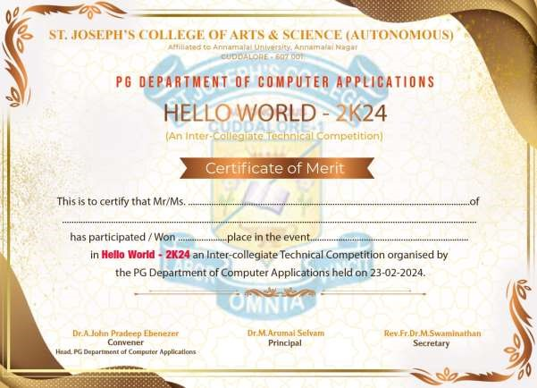

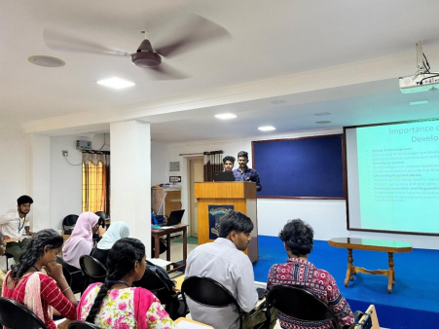 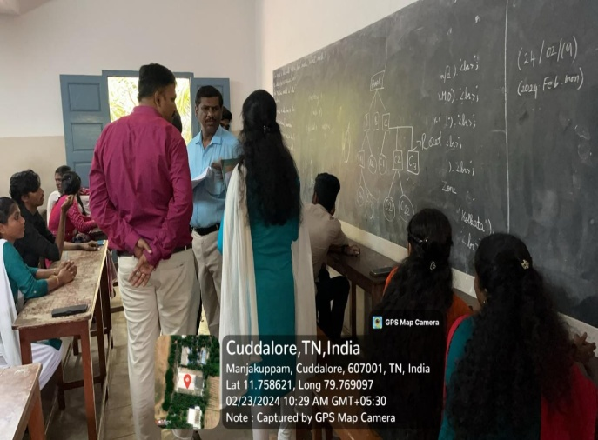

**Participants list**

|  |  |  |
| --- | --- | --- |
| SI.NO | **NAME** | **Name Of The College** |
|  | Lathefa .S | Achariya Arts & Science College |
|  | Rassika.K | Achariya Arts & Science College |
|  | Madhumidha.P | Jawahar Science College, Neyveli |
|  | Mohamed Mushraf.N | Jawahar Science College, Neyveli |
|  | Andrew Ben.P | Ifet College Of Enginnering |
|  | Madhumitha.S | Ifet College Of Enginnering |
|  | Kaviya.M | Ifet College Of Enginnering |
|  | Mahalakshmi.K | Ifet College Of Enginnering |
|  | Jayapriya.S | Krishnasamy College Of Engineering And  Technology |
|  | Mrithika.M | Krishnasamy College Of Engineering And  Technology |
|  | Madalvizhi. S | Ifet College Of Enginnering |
|  | Pragannayagi.S | Ifet College Of Enginnering |
|  | Vinotharasi.R | Ifet College Of Enginnering |
|  | Ganesh Kumar.V | Ifet College Of Enginnering |
|  | Thariq Basha.S | Achariya Arts & Science College |
|  | Vigneshvaran .J | Achariya Arts & Science College |
|  | Rithu Sharma.A.Y | Achariya Arts & Science College |
|  | Mery Febina.T | Achariya Arts & Science College |
|  | Vimalan.S | Pope John Paul Ii College Ofeducation |
|  | Pragathisha Raj.K | Pope John Paul Ii College Ofeducation |
|  | Praburam.B | Ifet College Of Enginnering |
|  | Kanimozhi.B | Ifet College Of Enginnering |
|  | Kayalvizhi.S | Jawahar Science College, Neyveli |
|  | Kayalvizhi.T | Jawahar Science College, Neyveli |
|  | Vikram .R | Saradha Gangadharan College |
|  | Ramya.S | Saradha Gangadharan College |
|  | Sivarajani.D | Government Arts College   C.Mutlur Cdm |
|  | Selvakumar .K | Government Arts College  C.Mutlur Cdm |
|  | Sachin.S | Government Arts And Science College  Vadalur |
|  | Prakashraj.K | Government Arts And Science College  Vadalur |
|  | Janarathan.S | Ifet College Of Enginnering |
|  | Abdulkalam .I | Ifet College Of Enginnering |
|  | Jayaprakash.V | Government Arts And Science College  Vadalur |
|  | Kaviya.K | Government Arts And Science College  Vadalur |
|  | Ezhilarasi.A | University College Of Engineering, Pandruti. |
|  | Ashwariya.A | University College Of Engineering, Pandruti. |
|  | Subalakshmi.V | Jawahar Science College , Neyveli |
|  | Anupriya.B | Jawahar Science College , Neyveli |
|  | Gnanaprakash.H | Pope John Paul II College Of Education |
|  | Harish.G | Government Arts And Science College Chidambaram |
|  | Priyatharshini.M | Dhanalakshmi Srinivasan Engineering College Of Arts And Science |
|  | Vignesh.J | Achariya Arts And Science College |
|  | Sewanthi.S | Achariya Arts And Science College |
|  | Buwaneshwari.L | Krishnasamy College (Women’s) |
|  | Sailaja.J | Krishnasamy College (Women’s) |
|  | Koshika.K | C.Kandaswaminaidu College Women |
|  | Sathish.S | Government Arts And Science College , Vadalur |
|  | Pavanjit.A | Saradha College |
|  | Varunidhibazin.V | Saradha College |
|  | Santhiya.P | Saradha College |
|  | Swathi.G | ES Arts And Science , Villupuram |
|  | Dhiviya.E | ES Arts And Science Villupuram |
|  | Badhman.K | Periyar Arts And Science, Cuddalore |
|  | Mohan.N | Acharya College |
|  | Muthukumar.R | IFET College |
|  | Gokul.R | IFET College |
|  | Iswariya.L | IFET College |
|  | Srinithi.K | University College Of Engineering, Panruti. |
|  | Manishta.M | University College Of Engineering, Panruti. |
|  | Akash.S | Jawahar Science College , Neyveli |
|  | Subalakshmi.M | Jawahar Science College , Neyveli |
|  | Muthu Raja.N | Pope John Paul II College Of Education |
|  | Monaj.K | Government Arts And Science College Chidambaram |
|  | Nivetha.K | Dhanalakshmi Srinivasan Engineering College Of Arts And Science |
|  | Akash.V | Achariya Arts And Science College |
|  | Abinaya.V | Achariya Arts And Science College |
|  | Deebiga.M | Krishnasamy College (Women’s) |
|  | Sowmiya.B | Krishnasamy College (Women’s) |
|  | Yogasri.R | C.Kandaswaminaidu College Women |
|  | Bhuvaneshwaren.K | Government Arts And Science College , Vadalur |
|  | Barath.S | Saradha College |
|  | Baraneedharan.B | Saradha College |
|  | Mukilan.S | Saradha College |
|  | Kaviya Mani.M | ES Arts And Science , Villupuram |
|  | Akasiyavarani.S | ES Arts And Science Villupuram |
|  | Arshathsahil.S | Periyar Arts And Science, Cuddalore |
|  | Narisrinivas.P | Acharya College |
|  | Rahul Naidu Govindhan | IFET College |
|  | Harishraj.N | IFET College |
|  | Elavarasi.E | IFET College |
|  | Abinaya.G | Jawahar Science College |
|  | Sivakandan.E | Jawahar Science College |
|  | Tamilmaran.R | Jawahar Science College |
|  | Shthya.J | Jawahar Science College |
|  | Sheela Devi.V | C.Kandaswaminaidu College For Women |
|  | Sharmila | C.Kandaswaminaidu College For Women |
|  | Rishika | Pope John Paul II College Of Education |
|  | Hugundan.S | Pope John Paul II College Of Education |
|  | Aravindhbala | Pope John Paul II College Of Education |
|  | Mercy Karunya.J | Pope John Paul II College Of Education |
|  | Logasri.M | University Of Enginnering, Panruti |
|  | Boobesh.S | University Of Enginnering, Panruti |
|  | Ajay.H | Achariya Arts & Science College |
|  | Prakash.K | Achariya Arts & Science College |
|  | Lokesh.N | Achariya Arts & Science College |
|  | Abishe.R | Achariya Arts & Science College |
|  | Prasanna.P | Government Arts College |
|  | Suriyaprakash. A | Government Arts College |
|  | Kishore.S | Dhanalakashmi Srinivasan Enginnering College |
|  | Premkumar.V | Dhanalakashmi Srinivasan Enginnering College |
|  | Srirammehesh.S | Dhanalakashmi Srinivasan Enginnering College |
|  | Arun.R | Dhanalakashmi Srinivasan Enginnering College |
|  | Jayaraj.S | IFET College Of Enginnering |
|  | Manoj.M | IFET College Of Enginnering |
|  | Vinal Raj | Saradha Gangadharan College |
|  | Devanathan.T | Saradha Gangadharan College |
|  | Abijith | Saradha Gangadharan College |
|  | Harish.V | Saradha Gangadharan College |
|  | Yuvaraj.P | Achariya Arts & Science College |
|  | Hruthikkar. J. S | Achariya Arts & Science College |
|  | Sanjay.G | University Of Enginnering, Panruti |
|  | Arunkumar.S | University Of Enginnering, Panruti |
|  | Hahesvaran.V | E.S Arts And Science College, Villupram |
|  | Thirumalaivasan .M | E.S Arts And Science College, Villupram |
|  | Rubika.K | Periyar Arts And Science, Cuddalore |
|  | Nithsh.K | Periyar Arts And Science, Cuddalore |
|  | Mohameothenik Hussain.S | IFET College Of Enginnering |
|  | Muralidharan | IFET College Of Enginnering |
|  | Shthish.B | IFET College Of Enginnering |
|  | Balaji.S | IFET College Of Enginnering |
|  | Santosh. S | Jawahar Science College |
|  | Narenmadhawan | Jawahar Science College |
|  | Pradeep Selaman. J | IFET College Of Enginnering |
|  | Narumatha. N | IFET College Of Enginnering |
|  | Nithisnkumar. S | Periyar Arts And Science, Cuddalore |
|  | Boobesh. S | Periyar Arts And Science, Cuddalore |
|  | Ajay. M | Achariya Arts & Science College |
|  | Tharun. S | Achariya Arts & Science College |
|  | Abinayasharaswathi .P | Achariya Arts & Science College |
|  | Safiya | Achariya Arts & Science College |
|  | Suriya Prakash.A | Achariya Arts & Science College |
|  | Sanjay Kumar.S | Dhanalakashmi Srinivasan Enginnering College |
|  | Jagadishwaran.E | Dhanalakashmi Srinivasan Enginnering College |
|  | Ganesh. A | IFET College Of Enginnering |
|  | Mohammed Riyaf Ali. M | IFET College Of Enginnering |
|  | Karunagaran. S | IFET College Of Enginnering |
|  | Kathiravan. M | IFET College Of Enginnering |
|  | Mohammed Thoufic. M | IFET College Of Enginnering |
|  | Arul Selvam. V | IFET College Of Enginnering |
|  | Arul Prakash. N. R | IFET College Of Enginnering |
|  | Muthuraja. N | IFET College Of Enginnering |
|  | Ragul. C. A | Government Arts College |
|  | Hruthirkinar.S | Government Arts College |
|  | Sanjay.G | University Of Enginnering, Panruti |
|  | Priyadharshini.E | University Of Enginnering, Panruti |
|  | Kanimozhi.B | Pope John Paul II College Of Education |
|  | Gukan | Pope John Paul II College Of Education |
|  | Sathish Kumar.J | Periyar Arts And Science, Cuddalore |
|  | Balaji.S | Periyar Arts And Science, Cuddalore |
|  | Sathosh.S | Jawahar Science College |
|  | Adithiyanajith | Jawahar Science College |
|  | Thulasimani.V | Jawahar Science College |
|  | Sathish.S | Jawahar Science College |
|  | Bhuvaneshwaran.K | Saradha Gangadharan College |
|  | Praveen.S | Saradha Gangadharan College |
|  | Baraneedharan | Saradha Gangadharan College |
|  | Manoj.M | Saradha Gangadharan College |
|  | Vimal Raj | Saradha Gangadharan College |
|  | Sheela Devi.V | Saradha Gangadharan College |
|  | Thamizharuni.V | KNC For Women, Cuddalore |
|  | Mohammed Alfar. K | KNC For Women, Cuddalore |
|  | Sandhiya. A | E.S Arts And Science College, Villupram |
|  | Gowtham.V | E.S Arts And Science College, Villupram |
|  | Deepika.V | E.S Arts And Science College, Villupram |
|  | Dharma Prakash.L | E.S Arts And Science College, Villupram |
|  | Manikandan.P | Krishnasamy Engineering College |
|  | Loganath.S | Krishnasamy Engineering College |
|  | Ayisha.M | Saradha Gangadharan College |
|  | Siva Shanmugan.K | Saradha Gangadharan College |
|  | Rohith.B | Saradha Gangadharan College |
|  | Aswin Raj.R | Saradha Gangadharan College |
|  | Ramesh.R | Jawahar Science College |
|  | Babyshalani.J | Jawahar Science College |
|  | Sridharshini.R | Pope John Paul II College Of Education |
|  | Gnagaprakash.M | Pope John Paul II College Of Education |
|  | Ragul .C.A | Govt.College Of Arts And Science, Chidambaram |
|  | Priyadharshini.E | Govt.College Of Arts And Science, Chidambaram |
|  | Kanimozhi.P | Pope John Paul II College Of Education |
|  | Gunasekaran.L | Pope John Paul II College Of Education |
|  | Gokul.L | Dhanalakashmi Srinivasan Enginnering College |
|  | Rishika.S | Dhanalakashmi Srinivasan Enginnering College |
|  | Sharmila.A | Pope John Paul II College Of Education |
|  | Subashini.K | Pope John Paul II College Of Education |
|  | Saranya.S | Krishnasamy College (Women’s) |
|  | Maheshwari.A | Krishnasamy College (Women’s) |
|  | Priyadharishini.R | Krishnasamy College (Women’s) |
|  | Lavanya.M | Krishnasamy College (Women’s) |
|  | Lalithambigai.M | Jawahar Science College |
|  | Vasanthi.S | Jawahar Science College |
|  | Clindon.K | Jawahar Science College |
|  | Gopinath.V | Jawahar Science College |
|  | Gugan.S | IFET College Of Enginnering |
|  | Yakash.M | IFET College Of Enginnering |
|  | Arul Prakash.N.R | IFET College Of Enginnering |
|  | Kiruba Sri | IFET College Of Enginnering |
|  | Thirumalaivasan | Periyar Arts And Science, Cuddalore |
|  | Kavipriya.K | Periyar Arts And Science, Cuddalore |
|  | Swetha.B | University Of Enginnering, Panruti |
|  | Archana.V | University Of Enginnering, Panruti |
|  | Subanu.A | Pope John Paul II College Of Education |
|  | Jayapriya.S | Pope John Paul II College Of Education |
|  | Mahalaksimi.K | Krishnasamy Engineering College |
|  | Dharmaprakash.L | Krishnasamy Engineering College |
|  | Manikandan.P | Krishnasamy Engineering College |
|  | Lathefa.S | Krishnasamy Engineering College |

**Organizing Secretaries**

 